install Github for Windows
http://help.github.com/set-up-git-redirect

Github for Windows使用图文教程
http://www.cr173.com/html/15618_1.html

First time to use?
-apply GIT account via Github for Windows UI.
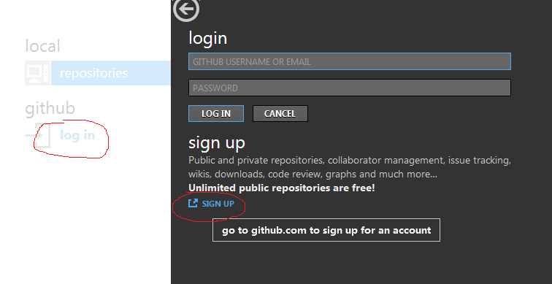

Already have GIT account:
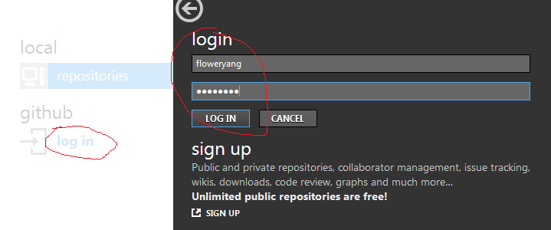
Basic GITHUb operations:
-create repo: 
-pull, edit, push(sync) via “Github for Windows”
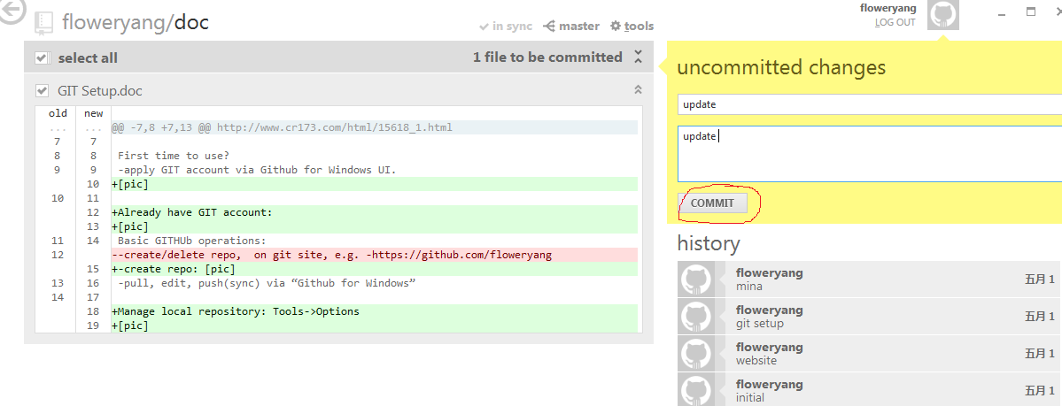

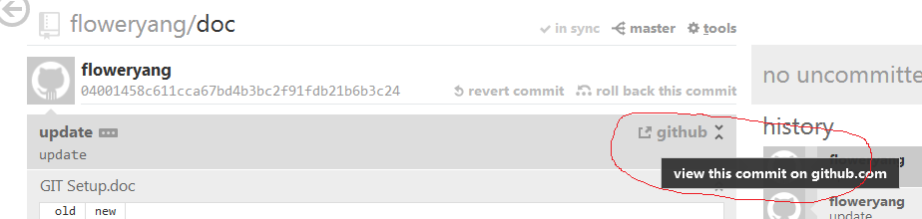

View on GIT and locally:
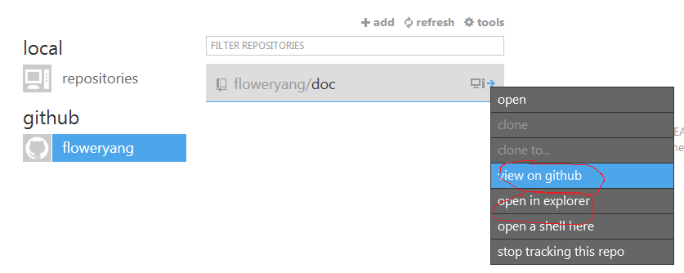

Manage local repository location: Tools->Options
